Node and React Assessment

Step 1: Installation and setup of database(wfm).

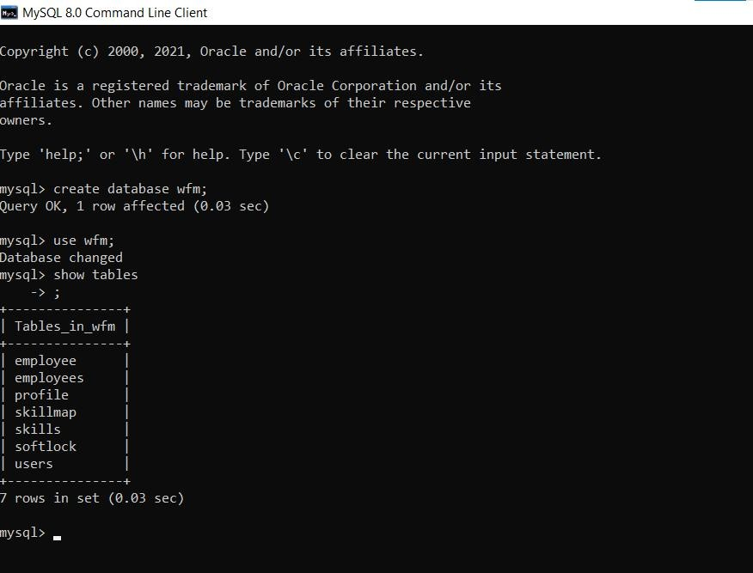

Step 2: Listing of Employee data respective to the user(Manager) in the Table

1. In node

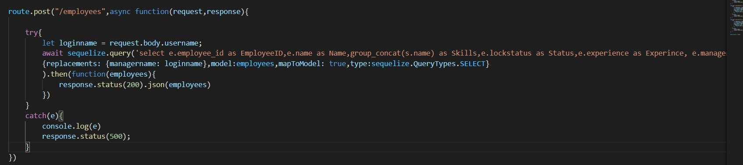

b. In react

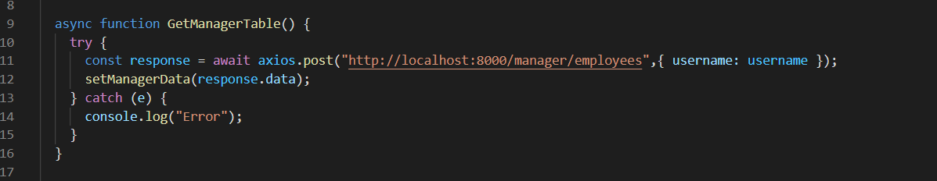

Step 4: Listing of Requestee, Requested date, manager data respective to the user(wfmManager) in the table.

1. 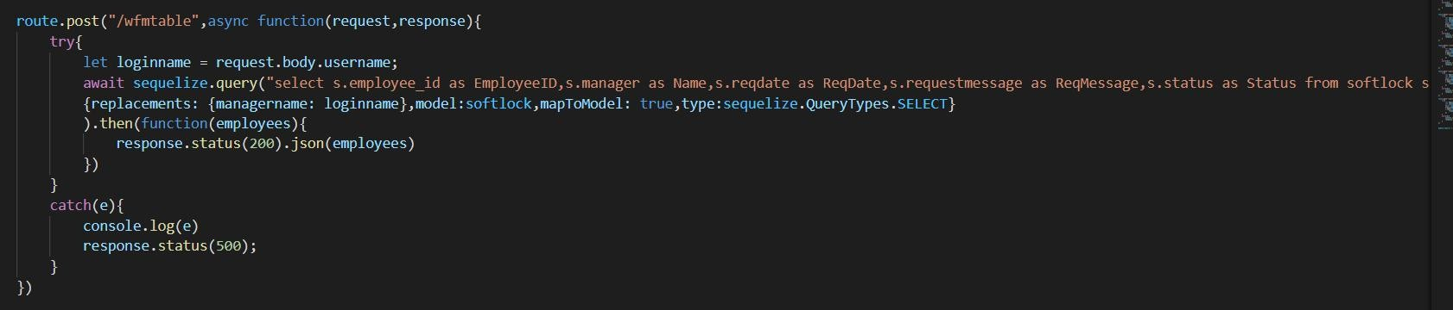In Node

B.In react

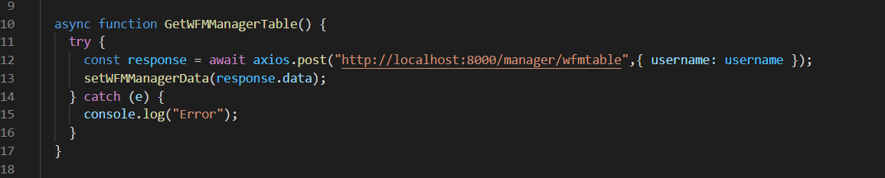

Step 5: Getting the value from the manager page popup for updating the status and to insert the message in the softlock(table).

1. In node.

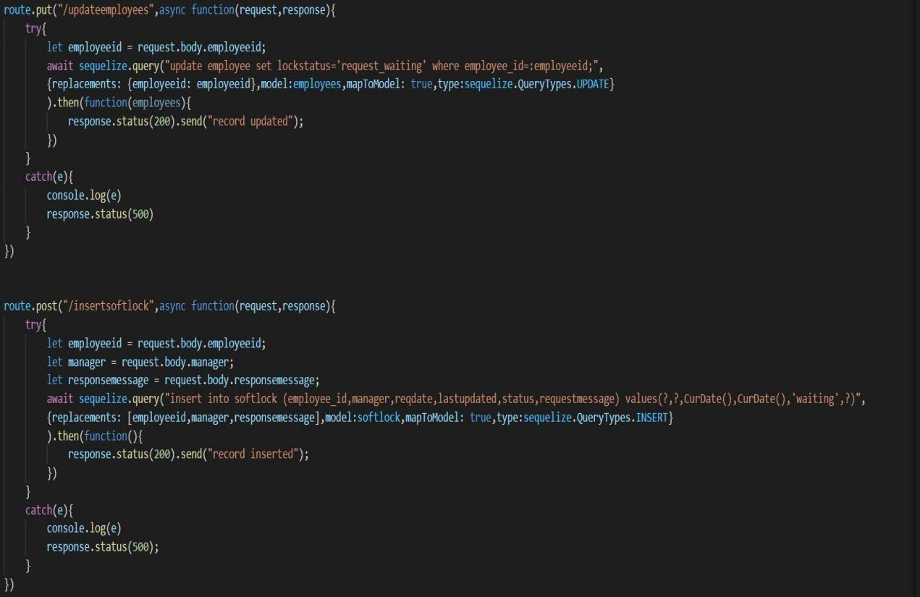

1. In react

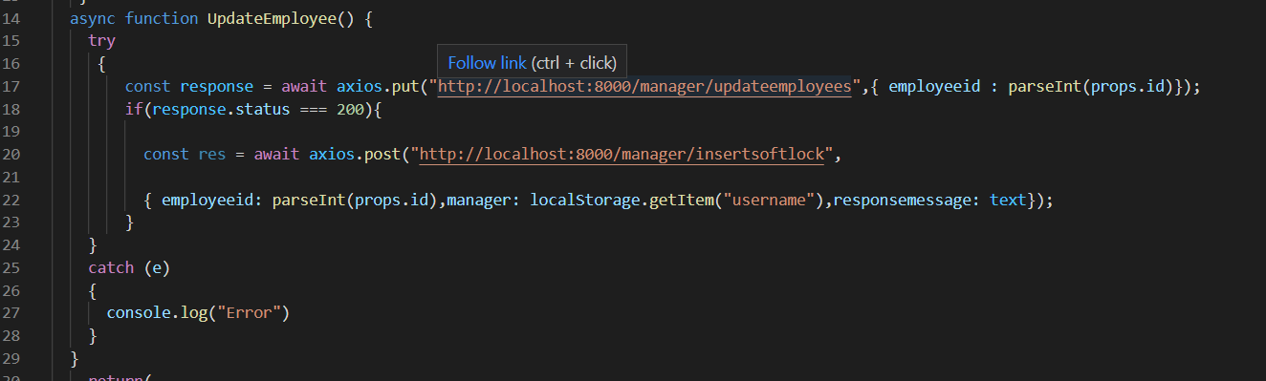

step 6: Getting the value from wfmManager page popup for changing the request sent by the manager.

1. In node

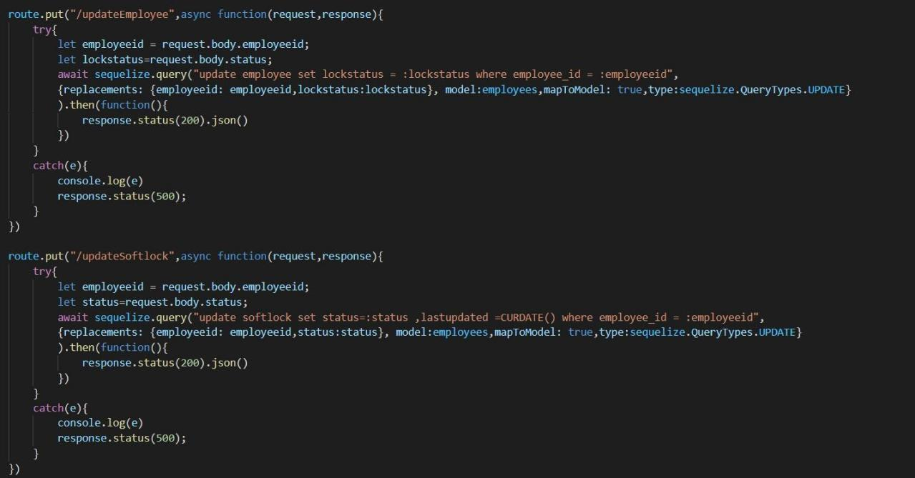

1. In react

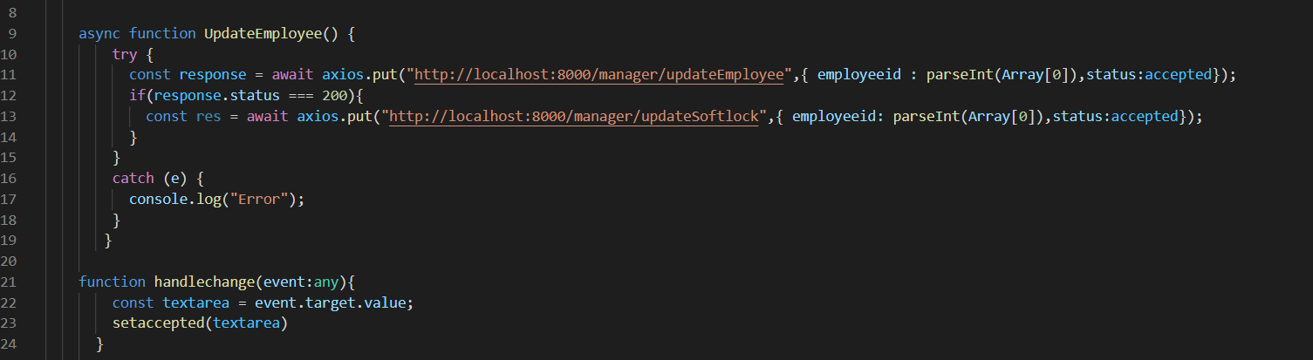

Step 7: Manager Login Page

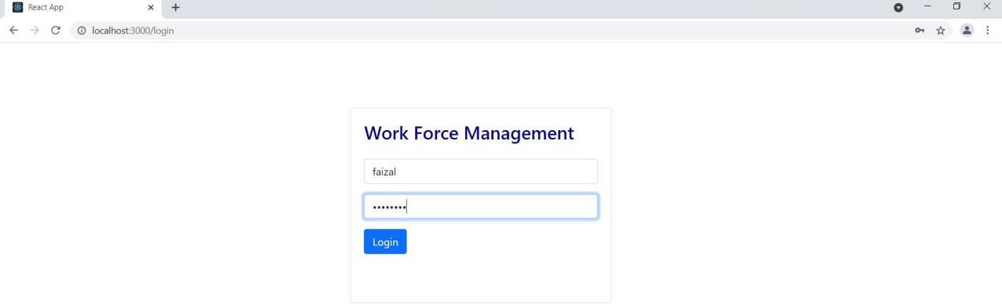

Step 8: Manager page respective to the user(manager).

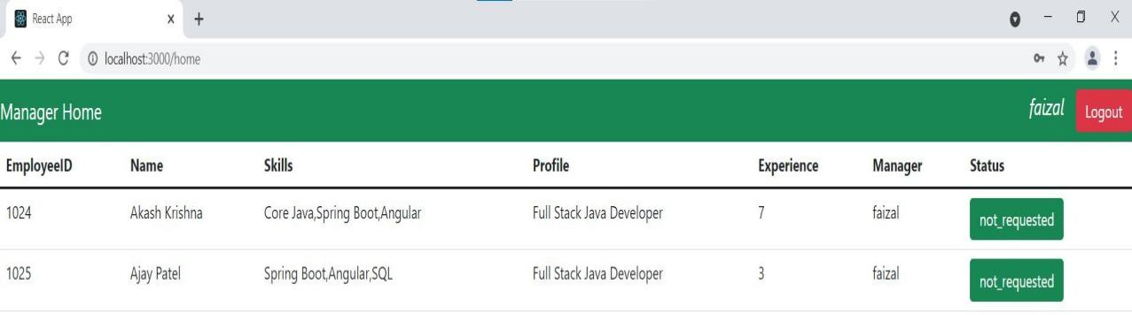

Step 9: Pop-up of manager page to give request to wfmManager.

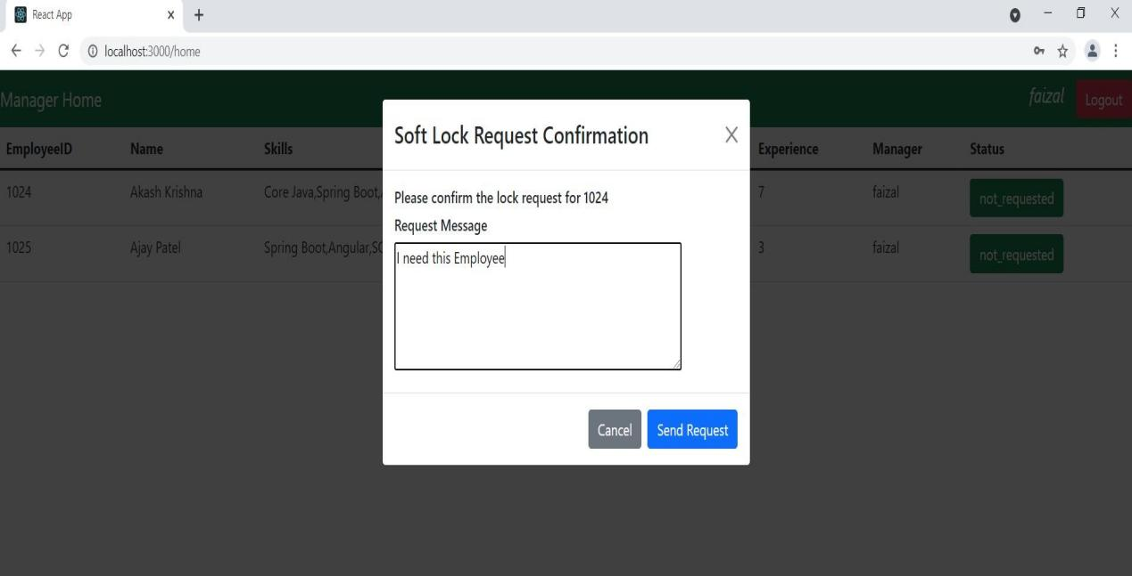

Step 10: wfmManager Login Page.

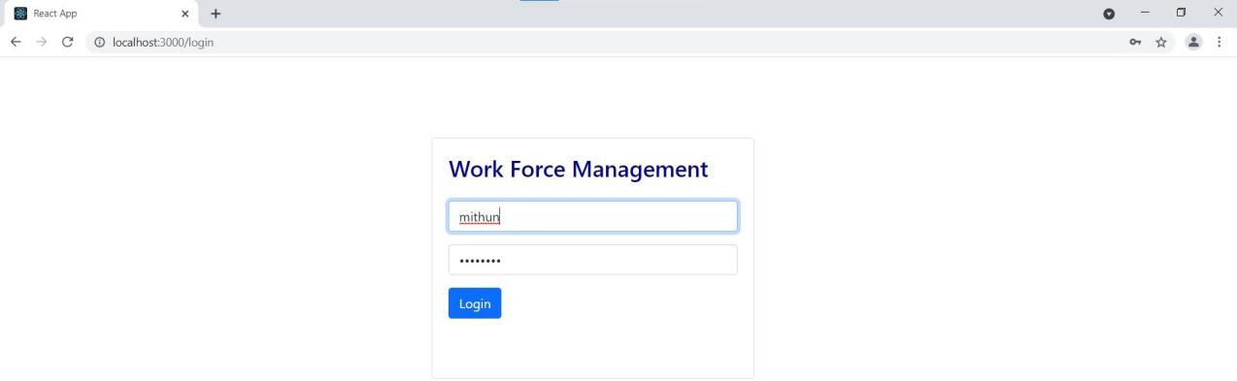

Step 11: wfmManager page respective to the user(wfmManager).

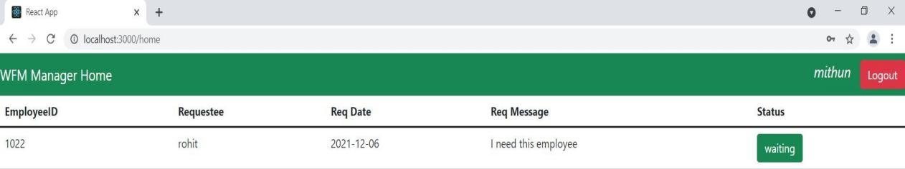

Step 12: Pop-up of wfmManager page to accept or reject the request sent by Manager.

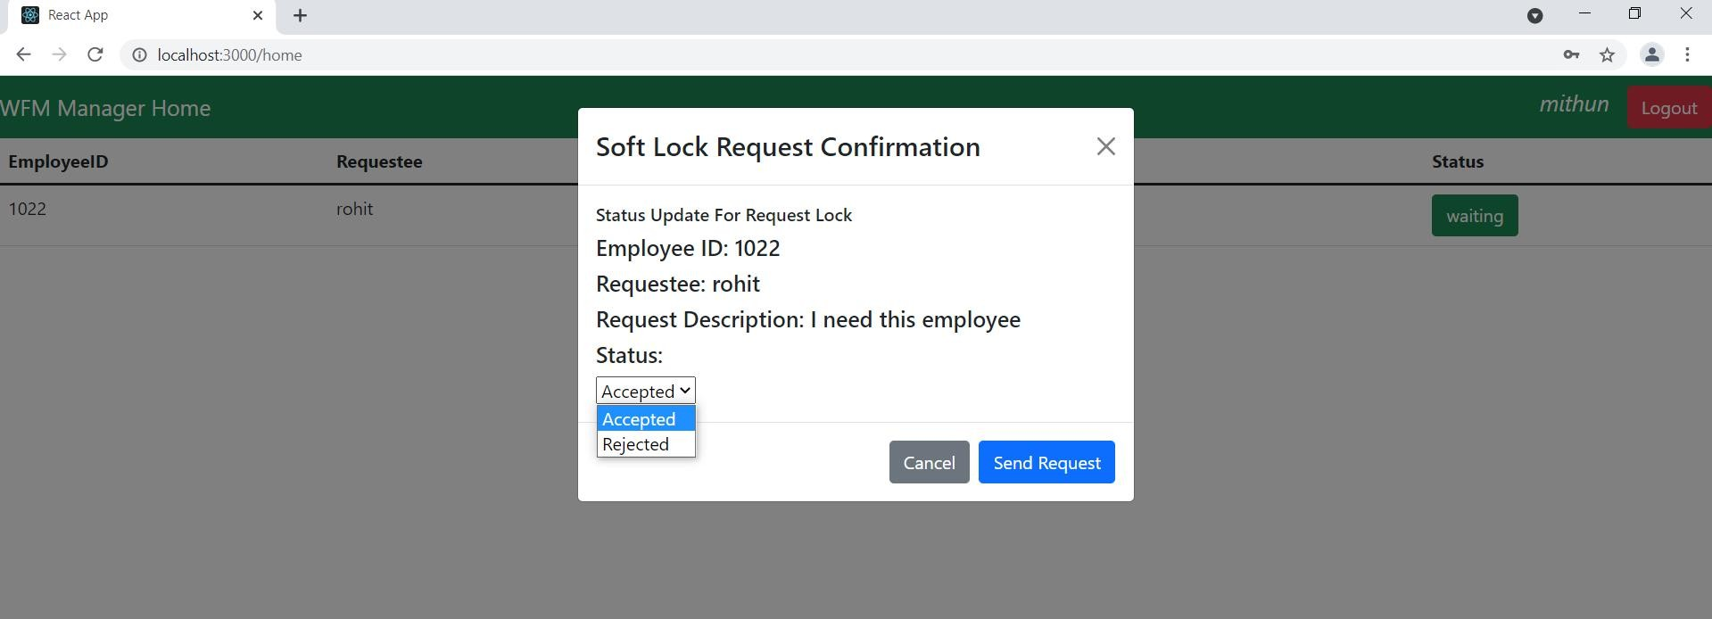

**Thank You.**